Task 0 : Explain what you are doing/ going to accomplish

Get my python server running, including constructing my class and menu.

Task 1: Sketch interface design

*Draft a rough design for the interface that allows the user to trigger functionality in task 1, while also annotating where the information in task 2 will be displayed. Create another sketch listing the interface widgets used to create the interface.*

N/A

Task 2: Identify any classes required

*Explain what the class will represent, plus listing what information will be stored in the class and any functions the class will have.*

Will have a class that contains my menu and the variables. Will help with displaying my info to the user when linking python to HTML.

Task 3: Identify information to be displayed

*What information will the interface need to display to the user?*

N/A

Task 4: Identify user inputs

*What program functions can the user trigger through the interface?*

N/A

Task 5: Identify any constants or existing data if required

Test data:

* Sushi Roll pack - Starting with 5
* Hot dog and Chips - starting with 12
* Ham and Cheese Sandwiches - 4 in stock

Task 6: Identify indexed data structures

N/A

Task 7: Determine what calculations are necessary

*Write out the calculations the program will have to compute.*

N/A

Task 8: Develop a modular structure for your program

*Describe any functions that the computer program will have, identifying any sub-functions where required.*

N.A

Task 9: Define the functions identified

*Describe the functions for both the main program and any classes in terms of input and/or output where required. You may choose to do this with flow charts or pseudo-code (not Python code!). Add in additional steps or explanations using sequential, conditional, iterative statements where required. Identify global and/or local variables.*

From bottle import run, route, view, get, post, request, static_file

Form itertools import count

Class canteen_food

Set _ids to count(0)

Define __initialise__(self, name, image, stock, description)

Set self.id to next(self._ids)

Set self.food_name to name

Set self.food_image to image

Set self.food_stock to stock

Set self.food_price to price

Set self.food_description to description

Set Canteen_test to [

Canteen_food(“Sushi Roll Pack”, “image”, “5”, “price” “description”)

Canteen_food(“Hot Dog and chips”, “image”, “12”, “price” “description”)

Canteen_food(“Ham and Cheese Sandwich”, “image”, “4”, “price” “description”)

Run(set host to “0.0.0.0”, set port to 8080, set reloader to true, set debug to true)

Task 10: Address any relevant implications such as usability, functionality, legal/ethical requirements.

N/A

Task 11: Document test cases for testing the program

*Document any testing that can be used to test your program. If any input is inputted using the keyboard, describe the expected input, plus any exceptional, boundary or invalid cases.*

If there is no error messages then I can expect the code to be working, although I will have no way of testing this till version 2 when I create my index page.

Task 12: Refine the plan

*Note any modifications here when iterating through the development cycles.*

*Needed capital T for true on the last line* Run(set host to “0.0.0.0”, set port to 8080, set reloader to true, set debug to true). Also when giving arguments to my class I forgot to include price so I was using but not giving an argument.

Task 13: Document testing

*Show screenshots of your program working with descriptions of each image. These images should test the tests cases listed above.*

The below picture shows my program running without any errors. I will know just how well this works in my next version when I add my index page.

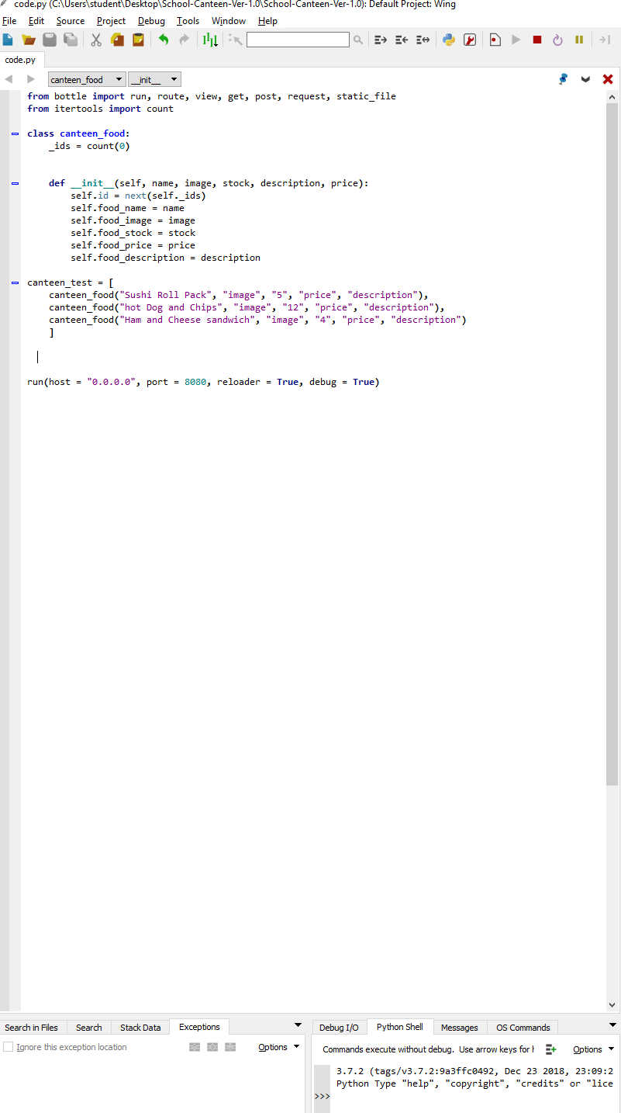

Task 14 : Evaluation

*How did your version turn out*

Good, will know the full extent of how well it works when I add my index page in the next version.